ANED 2014 Task 5 – European semester country fiche on disability

Country: Latvia

Author(s): Daina Calite-Bordane
With comparative data provided by the ANED core team

The Academic Network of European Disability experts (ANED) was established by the European Commission in 2008 to provide scientific support and advice for its disability policy Unit. In particular, the activities of the Network will support the future development of the EU Disability Action Plan and practical implementation of the United Nations Convention on the Rights of Disabled People.

This country report has been prepared as input for the Flash synthesis report on the European Semester.

Summary of the overall situation and challenges

The overall situation on the labour market continues to improve; the number of jobs and wages is increasing and unemployment reducing. The State Employment Service continues to implement different active labour market programs including those for disabled people and young people. The level of registered unemployment in July 2014 was 8.6% - the lowest since the end of 2008. At the same time the proportion of registered disabled unemployed persons increased from 9.4% in 2012 to 9.9% in 2013 and to 10.6% in July 2014. There is no specific data about the number of employed disabled persons.

In the field of education, comparable data about disabled children practically are not available. In recent years the number of special schools decreased from 63 such special education institutions in 2010/2011 to 61 special education institutions in 2012/2013. The number of children in special schools also decreased from 8435 in 2010/2011 to 7088 in the 2013/2014 education year. There is a lack of comparable data. Data in Latvia have been collected about children with special needs, which do not always mean children with disability.

Small, positive changes can be identified regarding proportions of poor persons - during 2013, the proportion of poor persons in the total population declined from 5.4% in January to 4.1% in December. From July 1, 2014, state support for persons with disabilities increased. Specific data on the national level about disabled people and poverty is not available. Persons with disabilities are considered as a separate social group at risk, but in-depth studies are not carried out.

During 2013-2014 several political documents were prepared with respect to the Europe 2020 headline targets - the Guidelines on Inclusive Employment 2014-2020 and Guidelines for Education Development 2004-2020. The most important are the Guidelines on the Implementation of the UN Convention on the Rights of Persons with Disabilities 2014-2020, Main activities planned are in the field of labour and employment, social security and public awareness.

Assessment of the situation of disabled people with respect to the Europe 2020 headline targets

Strategic targets

Table 1: Europe 2020 and agreed national targets for the general population
 | Europe 2020 targets | National targets
Employment | 75% of the 20-64 year-olds to be employed | 73%
Education | Reducing the rates of early school leaving below 10% | 10%
Education | At least 40% of 30-34–year-olds completing third level education | 34-36%
Fighting poverty and social exclusion | At least 20 million fewer people in or at risk of poverty and social exclusion | 121,000 (at risk of poverty after social transfers and/or living in households with very low work intensity)

Any relevant disability targets from national strategies or sources:
Guidelines on the Implementation of the UN Convention on the Rights of Persons with Disabilities 2014-2020 provides an action 2. Labour and Employment. The target of this action is to take measures for inclusion of disabled persons into the labour market by provision of appropriate support, taking into account the type of functional disorder.

Perfomance indicator | 2011 | 2017 | 2020
Numer of employed in subsidised working places | 497 (2012) | 600 | Increases (number of employed persions with severe disability)*
Number of employed persons with mental disorders | 0 | 40 | Increases
The proportion of employed persons with disabilities (%) | 20,7 | 30 | Increases
Number of persons involved in active labour market measures | 13051 | 17000 | Increases
* Note: Regarding planned results in 2020 it is only stated that numbers or propotions will increase.

A note on the use of EU data
Unless specified, the summary statistics presented in this report are drawn from 2012 EU-SILC micro data. The EU-SILC sample includes people living in private households and does not include people living in institutions. The proxy used to identify people with disabilities (impairments) is whether ‘for at least the past 6 months’ the respondent reports that they have been ‘limited because of a health problem in activities people usually do’. Responses to this question vary between countries and national data sources are added for comparison, where available.

Table 2: Self-reported ‘activity limitations’ as a proxy for impairment/disability (EU-SILC 2012)
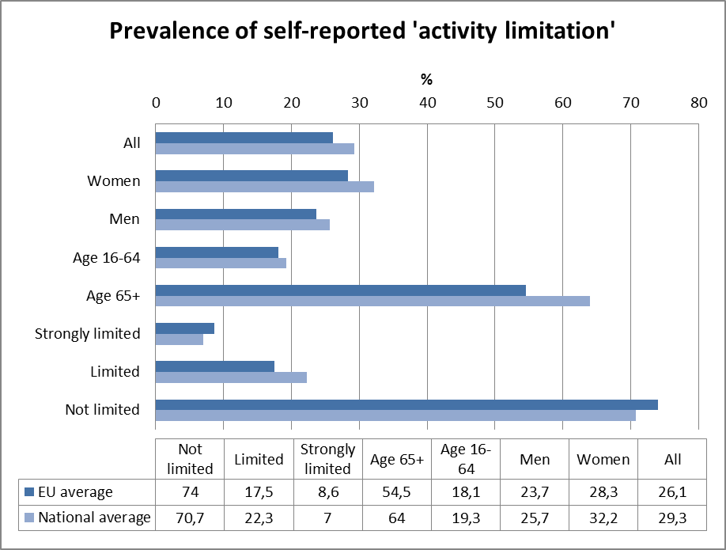
Source: EUSILC UDB 2012 – version 2 of August 2014

In subsequent tables, these data are used to estimate outcomes for ‘disabled’ people in the main target areas for EU2020 – employment, education and poverty risk. Due to the small number of observations for young people (aged 16-24) caution should be attached to interpreting results for this age group.

Employment data

Table 3: Most recent employment data, aged 20-64
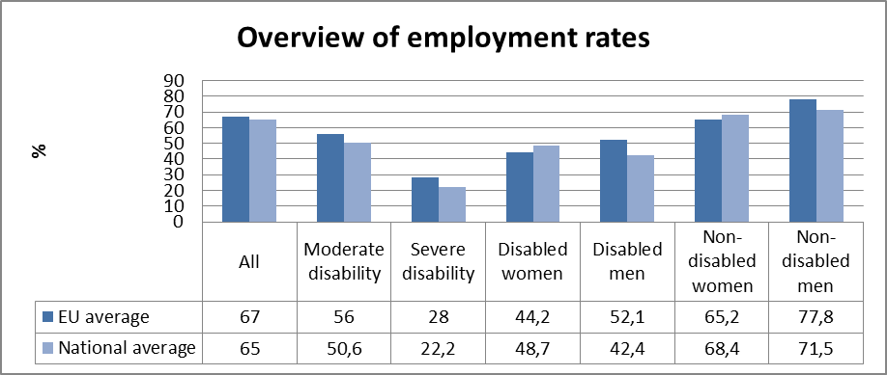

Table 4: Employment rate data, by age group
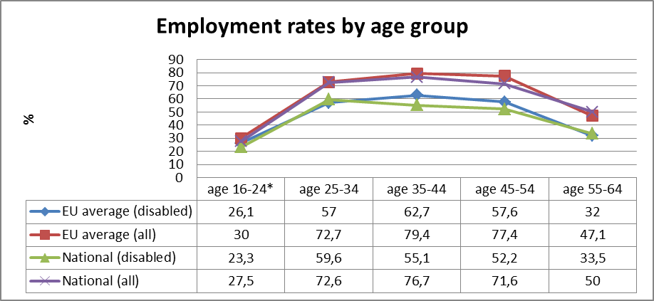
Table 5: comparison of data from EU-SILC (2012) and the LFS ad hoc disability module (2011)
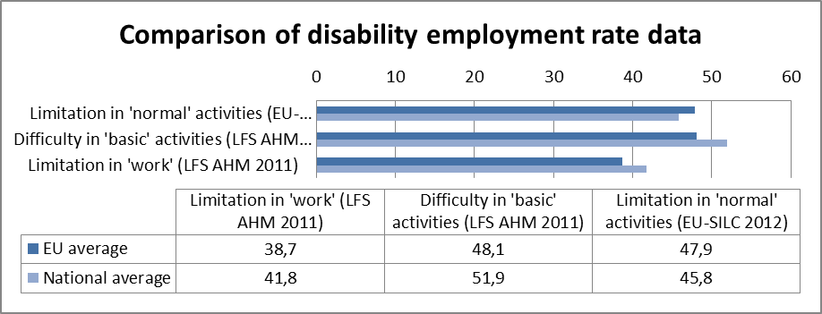
Source: EUSILC UDB 2012 – version 2 of August 2014, and Eurostat LFS AHM 2011

Table 6: Five-year trends in employment by gender and disability (aged 20-64)
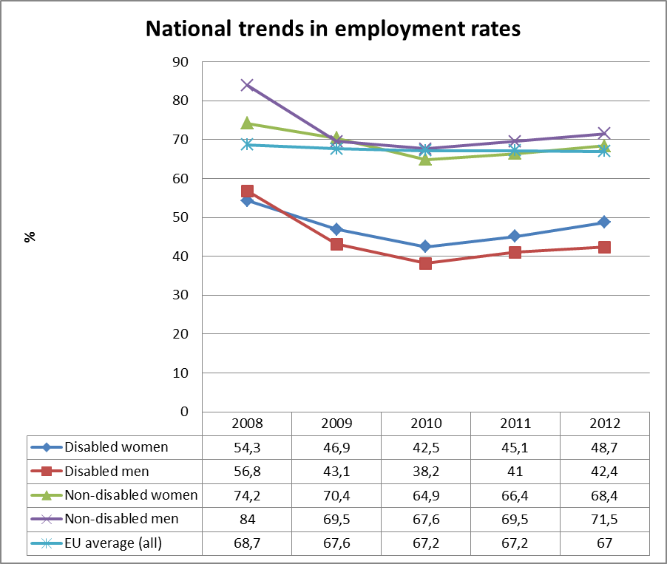
Source: EUSILC UDB 2012 – version 2 of August 2014 (and preceding UDBs)

Alternative data on disability and employment from national sources:
The employment rate of disabled persons depends on the severity of disability. There is no specific data about number of employed disabled persons, but according to the information from the Guidelines for the implementation of the UN Convention on the Rights of Persons with Disabilities 2014-2020 the higher employment rate is for persons with III disability group (loss of working abilities 25-59%) – more than 1/3 of these persons are employed or self-employed. The employment rate for persons with II disability group (loss of working abilities 60-79%) is 15.5%, but the lowest level, only 4.1% for persons with I group (severe disability – loss of working abilities 80-100%). Approximate data about number of employed disabled persons can be obtained from the State Revenue Service which accounted disabled persons receiving tax reliefs. According to the information from the civil servant of the Ministry of Welfare there are approximately 18 000 employed women and 18 000 employed men with disabilities.

Unemployment

National administrative rules and definitions of ‘unemployment’ may affect the way in which people with disabilities are categorised in different countries.

Table 7: Most recent unemployment data, aged 20-64
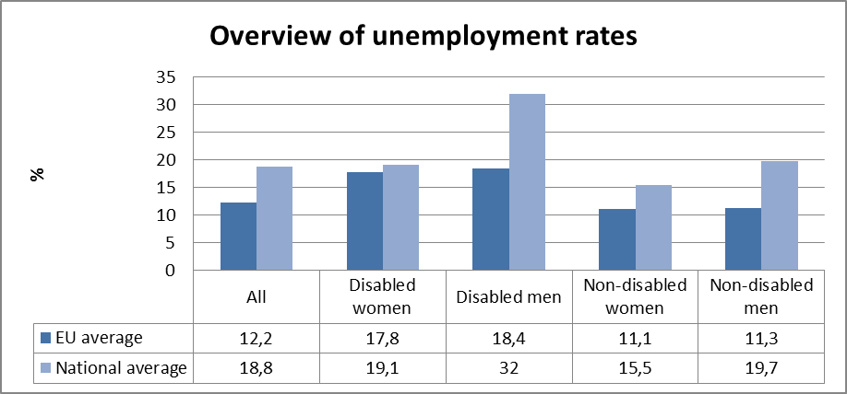
Source: EUSILC UDB 2012 – version 2 of August 2014
Table 8: Unemployment rate data, by age group
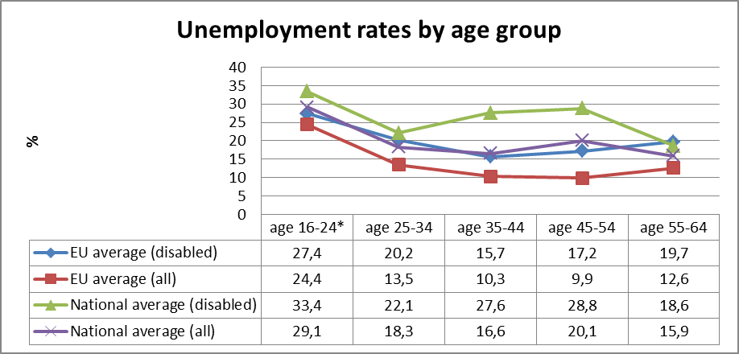
Source: EUSILC UDB 2012 – version 2 of August 2014

Alternative data on disability and unemployment from national sources:
According to the information from the State Employment Service the level of registrated unemployment rate in July 2014 was 8.6% - the lowest from the end of 2008.

Registered unemployment rate in the country was the following:
Year | 2008 | 2009 | 2010 | 2011 | 2012 | 2013 | 2014 July
Level, % | 7.0 | 16.0 | 14.3 | 11.5 | 10.5 | 9.5 | 8.6

The State Employment Service also has data about unemployment rates by age groups, but the ranking differs from the data in Table 8.

The unemployment rates by age group and gender (31.07.2014) are such:
Age group | Proportion (%) | Women | Men | Total number
15-19 | 1.0 | 448 | 388 | 836
20-24 | 8.0 | 4076 | 2567 | 6643
25-29 | 10.7 | 5676 | 3259 | 8935
30-34 | 9.9 | 5101 | 3147 | 8248
35-39 | 10.0 | 4921 | 3423 | 8344
40-44 | 11.0 | 5114 | 4023 | 9137
45-49 | 11.8 | 5326 | 4487 | 9813
50-54 | 15.6 | 6994 | 5947 | 12941
55-59 | 16,5 | 7467 | 6251 | 13718
60 and more | 5.5 | 2512 | 2036 | 4548

Another situation can be observed regarding the registered unemployment rate for disabled persons. During the last years there have been minor changes in the number of registered unemployed disabled persons.

The registered unemployment rate of disabled persons in the country was as follows:
Year | 2008 | 2009 | 2010 | 2011 | 2012 | 2013 | 2014 July
Number of disabled persons | 4458 | 7287 | 9345 | 9939 | 9799 | 9254 | 8839
Proportion, % | 5.6 | 4.1 | 5.8 | 7.6 | 9.4 | 9.9 | 10.6

A tendency is that the proportion of registered disabled unemployed persons has increased from 9.4% in 2012 to 9.9% in 2013 and to 10.6% in July 2014.

In the Guidelines for the implementation of the UN Convention on the Rights of Persons with Disabilities 2014-2020, it is indicated that at the end of 2012 there were 9799 registered unemployed persons with disabilities. Of these, 5127 or 52.3% were women and 4675 or 47.7% - men. 36.3% were disabled persons in the age group 45-54 years, 24.9% in the age group 55-59 years. It means that 2/3 from unemployed disabled persons were older 45 years. More than half or 57% registered unemployed disabled persons were long-term unemployed (they had been registered more than one year).

Economic activity

Table 9: Most recent economic activty data, aged 20-64
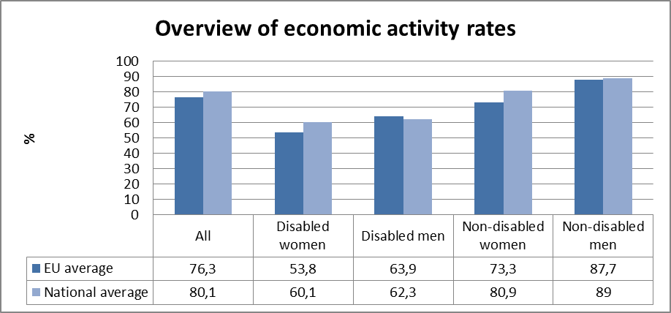
Source: EUSILC UDB 2012 – version 2 of August 2014

Table 10: Activity rate data, by age group
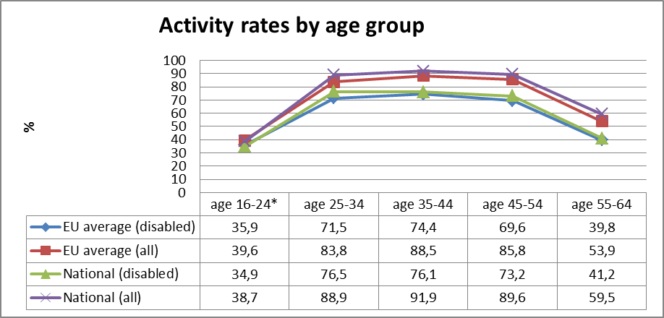
Source: EUSILC UDB 2012 – version 2 of August 2014

Alternative data on disability and economic activity from national sources:
No specific data from national sources.

Education data

EU statistical comparisons are more limited concerning the education of young women and men with disabilities in the EU2020 target age groups. Data is available from EU-SILC (annually) as well as the Eurostat Labour Force Survey ad-hoc disability module (for 2011), but with low reliability for several countries on the key measures. Using wider age range can improve reliability but estimations by gender remain indicative. EU trends are evident but administrative data may offer more reliable alternatives to identify national trends, where available.

Early school leavers

The EU-SILC sample for the target age group (aged 18-24) includes the following number of people reporting activity ‘limitation’ (as a proxy for impairment/disability).

Table 11: EU-SILC sample size in the target age group 18-24
 | No activity ‘limitation’ | Activity ‘limitation’ | Women reporting ‘limitation’ | Men reporting ‘limitation’
EU sample | 37,438 | 2,693 | 1,338 | 1,355
National sample | 1.184 | 98 | 43 | 55
Source: EUSILC UDB 2012 – version 2 of August 2014

Table 12: Early school leavers aged 18-24 (indicative based on above sample size)
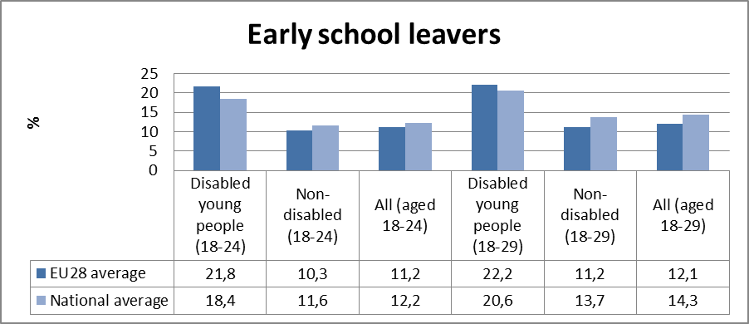

Alternative data on disability and early school leavers from national sources:
On the webpage of the Ministry of Education and Science, in the section Registers and Statistics, data about early school leavers is not specified.

In the 2012/2013 education year, from a total of 807 mainstream schools (with 200 706 students), 61 were special education institutions (with 7916 students). In 2010 / 2011 education year there were 63 such special education institutions.

According to the data from the Ministry of Education and Science the number of pupils in special schools and classes in the country decreases every year.

The number of school children in special schools and classes during most recent years was as follows:
School year | Number of school children (including those with disabilities)
2013./2014. | 7088
2012./2013. | 7916
2011./2012. | 7971
2010./2011. | 8435
2009./2010. | 8906
2008./2009. | 8760
2007./2008. | 9063

A more accurate and reliable picture of the situation or trends regarding early school leavers could be problematic due to lack of correct data about the number of people emigrating (including families with children).

It is also problem to find correct data about schoolchildren with disabilities in mainstream schools or special schools. Data were collected about children with special needs, which do not always mean children with disability.

Tertiary education

The EU-SILC sample for the target age group (aged 30-34) includes the following number of people reporting activity ‘limitation’ (a proxy for impairment/disability).

Table 13: EU-SILC sample size for the target age group 30-34
 | No activity ‘limitation’ | Activity ‘limitation’
EU sample | 25,596 | 2,801
National sample | 669 | 80
Table 14: Completion of tertiary or equivalent education (indicative based on above sample)
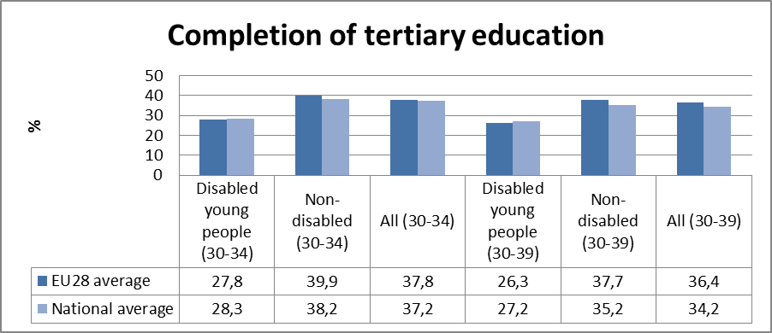
Source: EUSILC UDB 2012 – version 2 of August 2014

Alternative data on disability and tertiary education from national sources:
There are no specific data from national sources (registers or statistics from the Ministry of Education and Science).

Poverty and social exclusion data

EU SILC data provides indicators of the key risks for people with disabilities. In addition to household risks of low work intensity, there are risks of low income (after social transfers), and material deprivation. These three measures are combined in the overall estimate of risk. The risks for older people do not include work intensity (Eurostat refers to the age group 0-59 for this measure). The survey does not distinguish ‘activity limitation’ (the proxy for impairment/disability) for children under the age of 16. Relevant data from national sources is added where available.

Table 15: People living in household poverty and exclusion by key risk (aged 16-59)
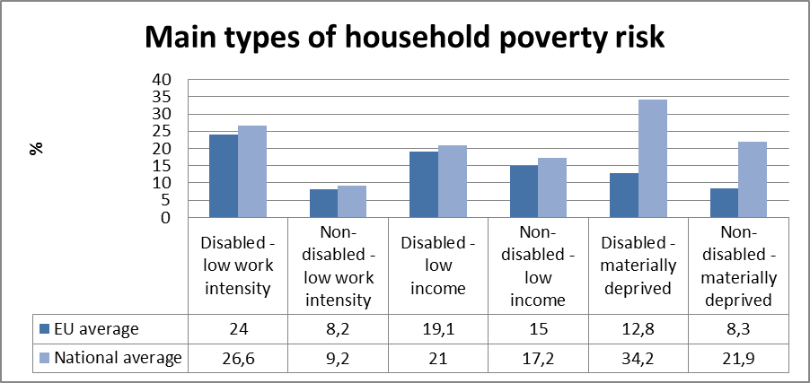
Source: EUSILC UDB 2012 – version 2 of August 2014

Table 16: People living in household poverty and exclusion by gender and severity (aged 16+)
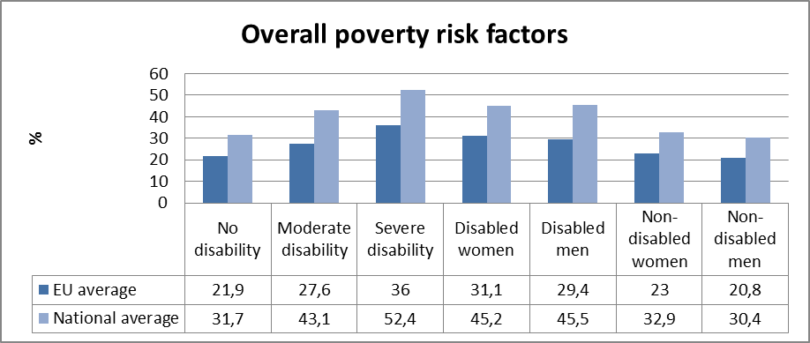
Table 17: Overall risk of household poverty by main age group (all, aged 16+)
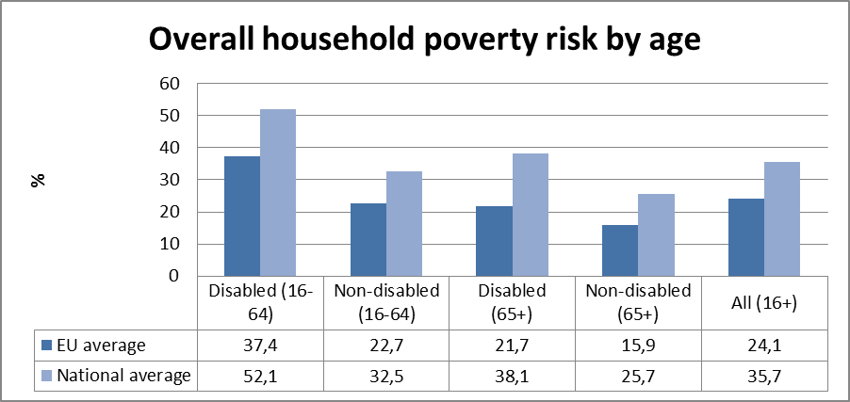
Source: EUSILC UDB 2012 – version 2 of August 2014

Table 18: Three-year trend in overall household risk of poverty and exclusion (EU-SILC 2012)
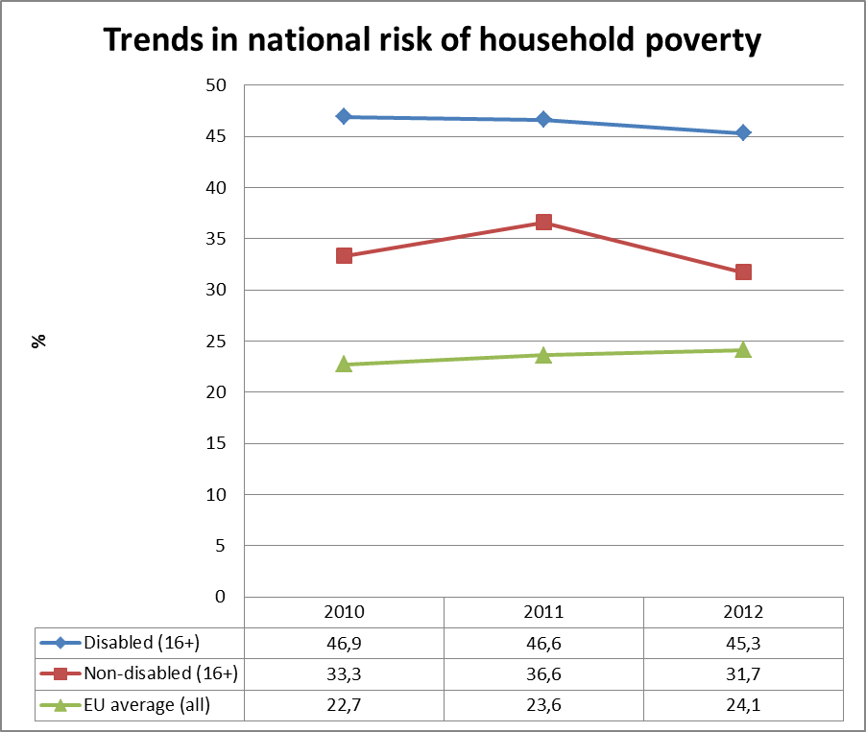
Source: EUSILC UDB 2012 – version 2 of August 2014 (and previous UDB)

Alternative data on disability and poverty risks from national sources:
Specific data on the national level about disabled people and poverty is not available. Persons with disabilities are considered as a separate social group at risk, but in-depth studies are not carried out.

In the World Bank's Scientific research: Latvia: “Who is Unemployed, Inactive or Needy? Assessing Post ‐ Crisis Policy Options” only disability is not clearly identifiable as main condition for unemployment and poverty. Other characteristics for groups with persistent labour-market difficulties are low education, chronic illness pre-pension age and inactivity.

Description of the situation and trends in relation to each target area

Employment

The overall situation on the labour market continues to improve; the number of jobs and wages increases, unemployment reduces. The State Employment Service continues to implement different active labour market programs. During 2013-2014 the State Employment Service carried out a pilot project. Project results will be used for development of new long-term unemployed activation programs. The program will be implemented in 2015 - 2020.

According to information from the State Employment Service the level of registered unemployment rate in July 2014 was 8.6% - the lowest since the end of 2008. The state Employment Service expects the that annual unemployment rate will be 9%.

At the same time the proportion of registrated disabled unemployed persons increased from 9.4% in 2012 to 9.9% in 2013 and to 10.6% in July 2014.

There is no specific data about number of employed disabled persons. Approximate data about number of employed disabled persons can be obtained from the State Revenue Sevice which counted disabled persons receiving tax reliefs. According to the information from the Ministry of Welfare there are approximately 18 000 employed women and 18 000 employed men with disabilities. The employment rate of disabled persons depends on the severity of disability - the higher employment rate is for persons with III disability group (loss of working abilities 25-59%) – more than 1/3 of these persons are employed or self-employed, employment rate for persons with II disability group (loss of working abilities 60-79%) is 15.5%, but the lowest level, only 4.1% for persons with I group (severe disability – loss of working abilities 80-100%).

Education

In the field of education comparable data about disabled children practically are not available. During recent years the Ministry of Education and Science has developed and the Saeima has accepted a strategic document - Guidelines for Education Development 2004-2020

During 2013 the Ministry of Education and Science implemented research on the effectiveness of special schools resulting in development of the informative report "On special education financing model". The Report was submitted to the Government on 10th April, 2014.

The number of special schools is decreasing – in the 2012/2013 education year from a total of 807 mainstream schools (with 200 706 students), 61 were special education institutions (with 7916 students). In 2010 / 2011 education year there were 63 such special education institutions.

There is lack of comparable data. Data in Latvia were collected about children with special needs, which do not always mean children with disability.

Poverty and social inclusion

The overall situation on diminishing of poverty and social inclusion stays on the same level. Small, positive changes can be identified regarding proportions of poor persons - during 2013, the proportion of poor persons in the total population declined from 5.4% in January to 4.1% in December.

From July 1, 2014, state support for persons with disabilities increased:

- The allowance for disabled people after the age of 18 who need care increased from 142 to 213.43 euros;
- Social security benefit for people in disability group 1 increased from 64 to 83.24 euros, for people with II disability group - from 64 to 76.84 euros, for people with I disability group since childhood - from 107 to 138.73 euros, but for people with II disability group since childhood - from 107 to 128.06 euros.

Funding for technical aids doubled in 2014, thus reducing the number of persons on the waiting list and increasing the number of people who received necessary technical aid.

During 2013-2014 the Ministry of Welfare organized a working group lead by the welfare minister (2013), the task of which was to develop proposals for reduction of poverty, social exclusion and inequality, and developed several political documents and concepts.

The Latvian Government recognised the impact of income inequalities on the poverty situation, thus in the Law on the medium-term budgetary framework for years 2014, 2015 and 2016, the Government defined reduction of income inequalities as one of the priorities of the budget.

At the same time actions for the reduction of poverty and social exclusion of disabled people are mainstreamed. Specific data on national level about disabled people and poverty is not available. Persons with disabilities are considered as a separate social group at risk, but in-depth studies are not carried out.

Assessment of policies in place to meet the relevant headline targets

National Reform Programme of Latvia for the Implementation of the Europe 2020 Strategy (Latvia’s NRP) has been adopted by the Cabinet of Ministers on April 26, 2011 and submitted to the European Commission on April 29, 2011. According to the European Semester process Latvia updates and submits Progress Reports on the annual basis.

Latvia uses a mainstreaming approach, however, disabled people are not recognised as a separate target group and disability related indicators are not analysed.

In overall planned measures in the field of employment, education and poverty reduction, described in the NRP Progress report, are adequate from the disability perspective.

In order to promote employment and foster labour mobility, in the programming period 2014–2020 it is expected to foster integration of the most disadvantaged unemployed (including disabled people) into the labour market, as well as integration of people at the risk of discrimination in the society and in the labour market.

Although there are not explicitly highlighted measures for increasing employment of people with disabilities, the provided measures for improving training activities for the unemployed, implementing support measures to reduce youth unemployment, efficient return of the long-term unemployed and social assistance clients to the labour market and supporting regional mobility, promoting self-employment and entrepreneurship as well as making the work of the State Employment Agency more efficient directly and indirectly may impact on reduction of unemployed people with disabilities and increase of proportion of employed people with disabilities.

In the education field an inclusive education focuses on two main target groups: children and youth at risk of exclusion due to their development, abilities or health condition and youth at risk of exclusion due to social conditions. Planned measures to increase the interest of general education schools, particularly teachers and heads of educational institutions in approaching each pupil individually and in developing a favourable educational environment to meet the pupils’ needs fully corresponds to the needs of children with disabilities. The same could be said regarding implementation of structural reforms in vocational education, modernization of higher education and promotion of cooperation among the partners involved in adult education regarding lifelong learning.

In the field of fighting poverty measures for reducing income inequality by encouraging people at risk of poverty and social exclusion (including disabled people) to participate in the labour market and improving of social protection measures focusing on families with children, directly and indirectly may leave an impact on situation of people with disabilities.

In addition it shall be noted that also planned measures: support for access to finances (Individual guarantees for enterprises, the micro-loan support programme), that may provide support also to people with disabilities in launching entrepreneurship and facilitating employment, as well as ensuring access to digital content and e-services, especially implementation of e-health services are relevant.

Employment

During 2013-2014 several political documents were prepared:

- the Guidelines on the Implementation of the UN Convention on the Rights of Persons with Disabilities 2014-2020;
- the Guidelines on Inclusive Employment 2014-2020;
- the informative report "Proposals for improvement of social security system";
- the concept On determination of minimum level of income.

From 2014 the State Employment Service implemented new support measures for unemployed youngsters - youth guarantees

Youth guarantees’ main target group is young people aged 15 to 24 years (inclusive). After registration with the State Employment Service, young people can receive necessary services in the form of qualified work, apprenticeships, internships as well as professional education. The State Employment Service offers these services within 4 months.

Education

During recent years the Government has accepted the documents:

- Guidelines for Education Development 2004-2020;
- The informative report "On special education financing model".
One of the Guidelines for Education Development 2004-2020 action lines is "inclusion of learners with special needs into the education system and introduction of the principle of inclusive education". The aim of this action is to extend access to education and to encourage all learners who are subject to exclusion, to participate and realize their potential and opportunities, particularly because persons with special needs are less likely to find a job or to be economically active in the future.

Poverty and social inclusion

During 2013-2014 the Ministry of Welfare developed several political documents and concepts:

- -The Guidelines on the Implementation of the UN Convention on the Rights of Persons with Disabilities 2014-2020;
- - The Guidelines on Inclusive Employment 2014-2020;
- - The informative report "Proposals for improvement of social security system";
- - The concept On determination of minimum level of income.

During 2015 it is planned to develop the concept on the possibility to determine the social pension base (August, 2015), concept on the possibility to determine the minimum level of unemployment benefit (December, 2015), concept on the possibility to restructure the costs of state social benefits or to review the extents of benefits, attaching them to certain socio-economic indicators (December, 2015) and to develop projects of legislative acts for provision of support to households with incomes lower than the national minimum income level (August, 2015).

Synergies between developments in the different areas

Measures for the achievement of national targets in employment, education and poverty and social inclusion areas are interlinked. The findings of the problems, necessary actions used the same available data. Employment possibilities and unemployment are discussed on the findings and linked with activities in the area of education. Unemployment problems and actions to reduce the unemployment level are closely linked with activities to reduce poverty.

Latvia uses a mainstreaming approach, thus it is difficult to find specific actions for disabled people and to understand whether or not disabled people will benefit from planned actions in strategic documents in the education field or employment field. All strategies or action plans were developed recently and it is too early to evaluate results or trends.
Specific actions regarding disabled people are included in the Guidelines on the Implementation of the UN Convention on the Rights of Persons with Disabilities 2014-2020. Main activities planned are in the field of social security and public awareness. The aim in the field of social security is to increase the welfare level of disabled persons by reduction of number of persons at risk of poverty and provision of targeted and effective state support accordingly to the type of functional limit.

It is planned:

  - that by more effective state support to disabled persons, the proportion of disabled persons, whose income is below the poverty risk threshold, from 19.4% (of total number of residents) in 2011 will decrease to 15% in 2017 and will continue to decline till 2020.
  - to develop new social services and to improve existing services for disabled people, resulting in increasing numbers of persons with I disability group with visual disability from 1185 in 2011 to 1900 in 2017; increasing number of disabled persons receiving assistant services in municipality from 0 in 2011 to 6647 in 2017; an increasing number of disabled persons receiving assistant services in higher education institutions from 0 in 2011 to 10 in 2017; increasing number of disabled persons receiving services of psychologist from 7 in 2011 to 100 in 2017.
  - to improve support for adaptation of housing (number of persons receiving support increased from 1 in 2011 to 100 in 2017), to increase number of disabled persons receiving income tax relief from 22% in 2011 to 35% in 2017.
  - to reduce number of those persons determined to be disability group 1 from 106 (per 1000 population) in 2001 to 95 (per 1000 population) in 2017, and to make more qualitative and clear the disability expertise process, resulting in a decrease of challenges to administrative actions from 717 in 2011 to 640 in 2017 and extending time for expertise from 45 minutes in 2011 to 60-80 minutes in 2017.
  - to develop support for disabled children under 5 years and their families (increase of assistant services from 0 in 2011 to 100 in 2017) and to establish rehabilitation divisions in municipal social services from 0 in 2011 to 30 in 2017.

The aim in public awareness activities is to encourage people with disabilities to exercise human rights and freedoms and live full, dignified lives. It is planned:

- to provide independent living possibilities, thereby reducing the number of disabled persons living in care institutions (per 10000 population) from 51in 2011, to 46 in 2017 and 35 in 2020.
- to develop the services of a support person, thus increasing the number of persons receiving support person services from 0 in 2011 to 200 in 2017;
- to provide accessibility in accordance with the type of disability – increase proportion of subtitling and translated into sign language programs from 10% in 2011 to 30% in 2017, proportion of accessible buildings and structures from 55% in 2011 to 80% in 2017, and proportion of accessible public transport from 5% in 2011 to 50% in 2017.

Regarding planned results in 2020 it is only stated that numbers or propotions will increase.

Regarding the activities already carried out, as positive trend must be mentioned the amendments to the Law on State Pensions (from October 1, 2013) about new disability pension calculation scheme for persons with I and II disability groups.

Follow-up of the disability perspective in the European semester

Progress on disability issues in the Country Specific Recommendations (CSRs)

Table 19: Policy measures related to achieving Recommendation #
Policy Measure
Exact date of adoption
Budget allocation
Stage of implementation
Is an independent evaluation planned?
Assessment of impacts in relation to the CSRs
Ambition sufficient to meet CSRs?
Credibility?

Other CSRs (not disability-specific) with a potential disability perspective/angle

One of the recommendations for Latvia within the period 2014-2015 was to reform social assistance and its financing further to ensure better coverage, adequacy of benefits, strengthened activation and targeted social services. Also to increase coverage of active labour market policies and improve the cost-effectiveness, quality and accessibility of the health care system (Recommendation No. 3).

During previous years (2013 and 2014) Latvia had developed several political and strategic documents including activities and solutions relevant to disabilities – in more detail in paragraphs 3 and 4 of this report.

Assessment of disability relevant issues in the Staff Working Document (SWD)

Comments relevant to disability in the Staff working document concern long-term unemployed disabled people, people with disabilities as a group at particularly high risk of poverty and social exclusion. Those comments are now being addressed (more information in paragraphs 3 and 4).

Assessment of the structural funds 2007-2013 / ESIF 2014-2020 or other relevant funds

Use of funds in relation to disability challenges

Disability issues are visible and described in all operational programs. The list of activities in welfare field is available http://sf.lm.gov.lv/lv/programmas/projekti/

The Ministry of Welfare, responsible for the coordination of policy on equal opportunities, provides information about projects and examples of best practice, which includes specific projects for target groups of certain kinds of disability and different fields - employment, infrastructure and social inclusion.

For example, in activity 3.1.4.1.1. financed by the European Regional Development Fund the State Medical Commission for the Assessment of Health Condition and Working Ability (further- State Commission) implements a project "Development of infrastructure and provision of scientific and technical basis in the State Commission for evaluation of working abilities and functional disorders".

Another project financed from the same fund, ensures education opportunities for persons with functional limitations in higher education institutions. During 2009-2013 in 20 higher education institutions the infrastructure has been upgraded, including adaptation of infrastructure for persons with disabilities and provision of equipment and technologies.

Within project (Nr.2010/0330/1DP/1.2.2.4.1/10/IPIA/VIAA/001) financed from the European Social Fund "Development of support system for leaners with functional limitations" during 2011-2013 instruments for diagnosis were developed for four clinical groups - mental retardation, speech/language disorders, specific learning difficulties and attention disorders. Specialists from the University of Liepaja, Latvian University and Rezekne Higher Education School have developed teaching materials for teachers working with students who have a variety of special needs - autism, behavioural disorders, learning disorders, visual disturbances, mental disorders and cochlear implants. Higher education institutions also developed information materials for parents and caregivers.

Preparations for ESIF 2014-2020

The Ministry of Welfare had published the project of Methology for Monitoring of the Implementation of the Principle "Equal opportunities" in 2014-2020. Information about preparations for ESIF 2014-2020, overall situation, planning documents, public involvement and other information is publicly available on the webpage of the Ministry of Finance www.esfondi.lv.
Gunta Anča, the Chair of the Board of the Latvian Umbrella Body for Disability organisations SUSTENTO was a member of the Interim Monitoring Committee of the EU Structural Funds and Cohesion Fund established by the Ministry of Finance decree No. 156 of September 25, 2012.

The Latvian Umbrella Body for Disability organisations SUSTENTO unites 42 different NGOs representing people with disabilities and patients. Therefore already since 2012 the NGOs of people with disabilities have possibilities to participate in preparatory work for 2014 - 2020 planning period. An opinion by the SUSTENTO Chair of the Board on ex-ante assessment of the EU Cohesion Policy Fund Action Program 2014-2020 is available at the home page of NGO (http://www.sustento.lv/resource/show/981).

On November 21, 2014 there was established a Monitoring Committee of EU Fund 2014-2020 planning period and on November 24, 2014 the Monitoring Committee approved members of the Committee having the right to vote, int.al. Mrs. Gunta Anča, the Chair of the Board of the Latvian Umbrella Body for Disability organisations SUSTENTO.

Having regard of the tasks set for the Monitoring Committee, the NGOs representing people with disabilities have the opportunity to participate in monitoring the use of financing of EU Funds, to review proposals on amendments in development planning documents, approve a plan on assessment of EU Funds; to review conclusions on assessment of EU Funds and recommendations on implementation of planning documents, as well as, with respect to the competence, perform other tasks set in legal acts of the Republic of Latvia and EU regulating the management of EU Funds.

Recommendations

No specific recommendation regarding policies. But there is a necessity to provide reliable statistics and data.

http://ec.europa.eu/europe2020/pdf/targets_en.pdf.
Guidelines for the implementation of the UN Convention on the Rights of Persons with Disabilities 2014-2020, polsis.mk.gov.lv/LoadAtt/file21919.doc.
EUSILC UDB 2012 – version 2 of August 2014.
The SILC survey questions are contained in the Minimum European Health Module (MEHM) http://epp.eurostat.ec.europa.eu/statistics_explained/index.php/Glossary:Minimum_European_Health_Module_(MEHM).
The methodology is further explained in the annual statistical reports of ANED, available at http://www.disability-europe.net/theme/statistical-indicators.
Guidelines for the implementation of the UN Convention on the Rights of Persons with Disabilities 2014-2020, polsis.mk.gov.lv/LoadAtt/file21919.doc.
The uneployment situation in the country (July, 2014) http://www.lm.gov.lv/upload/darba_tirgus/darba_tirgus/petijumi/parskats_par_bezdarba_situaciju_valsti_2014gadajulijs.pdf.
The uneployment situation in the country (July, 2014) http://www.lm.gov.lv/upload/darba_tirgus/darba_tirgus/petijumi/parskats_par_bezdarba_situaciju_valsti_2014gadajulijs.pdf.
The uneployment situation in the country (July, 2014) http://www.lm.gov.lv/upload/darba_tirgus/darba_tirgus/petijumi/parskats_par_bezdarba_situaciju_valsti_2014gadajulijs.pdf.
Guidelines for the implementation of the UN Convention on the Rights of Persons with Disabilities 2014-2020, page 13, polsis.mk.gov.lv/LoadAtt/file21919.doc.
For the LFS AHM data see, Early school leavers http://appsso.eurostat.ec.europa.eu/nui/show.do?dataset=hlth_de010&lang=en and tertiary educational attainment http://appsso.eurostat.ec.europa.eu/nui/show.do?dataset=hlth_de020&lang=en.
Guidelines for the implementation of the UN Convention on the Rights of Persons with Disabilities 2014-2020, polsis.mk.gov.lv/LoadAtt/file21919.doc.
http://izm.izm.gov.lv/registri-statistika/statistika-vispareja/11069.html.
Scientific research: Latvia: “Who is Unemployed, Inactive or Needy? Assessing Post ‐ Crisis Policy Options”, p.83, http://www.lm.gov.lv/upload/aktualitates/latvia_compwbs.pdf.
Information from the Ministry of Welfare.
http://m.likumi.lv/doc.php?id=266406.
http://tap.mk.gov.lv/mk/tap/?pid=40319531.
http://www.lm.gov.lv/text/1382.
http://ec.europa.eu/europe2020/pdf/csr2014/nrp2014_latvia_en.pdf, p.54.
Ibid, p.60.
Ibid, p.60.
http://ec.europa.eu/europe2020/pdf/csr2014/nrp2014_latvia_en.pdf, p.72
Ibid, p.37
Ibid, p.49
polsis.mk.gov.lv/LoadAtt/file21919.doc
http://tap.mk.gov.lv/lv/mk/tap/?pid=40331535
http://tap.mk.gov.lv/mk/tap/?pid=40330153
Informative report "On Implementation of Youth guarantees in Latvia 2014-2018", http://www.lm.gov.lv/upload/jauniesiem/lmzin_jg_171213.pdf
http://tap.mk.gov.lv/mk/tap/?pid=40305684
http://tap.mk.gov.lv/mk/tap/?pid=40319531
polsis.mk.gov.lv/LoadAtt/file21919.doc.
http://tap.mk.gov.lv/lv/mk/tap/?pid=40331535.
http://polsis.mk.gov.lv/view.do?id=4595.
http://tap.mk.gov.lv/mk/tap/?pid=40330153.
polsis.mk.gov.lv/LoadAtt/file21919.doc.
http://likumi.lv/doc.php?id=258301
http://sf.lm.gov.lv/f/files/METDOIKA_HP_VI_13102014.pdf
http://www.esfondi.lv/page.php?id=346.
http://www.esfondi.lv/upload/14-20_gads/FMRik_20120925_Nr_516.pdf.
http://www.sustento.lv/section/show/4.
http://www.esfondi.lv/upload/14-20_gads/MK_rikojums_par_UK_14-20_sastavu_%2821112014%29.pdf.
http://www.esfondi.lv/upload/14-20_gads/Lemums_par_UK_14-20_personalsastavu_%2824112014%29.pdf.
http://likumi.lv/doc.php?id=221906.

